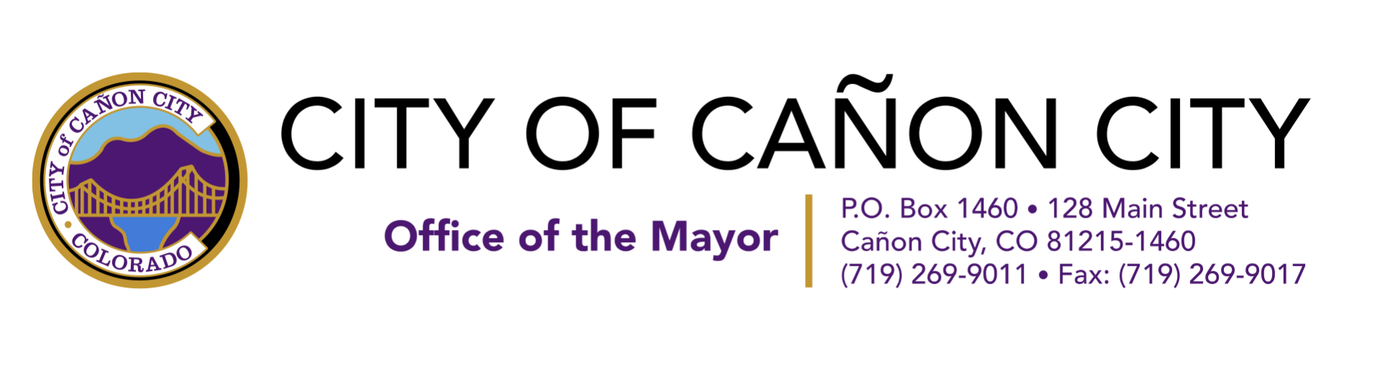
Please take time and consider the plight of our many small businesses that have been incredibly excited to open their doors today, after being closed for weeks, to start earning a living again. Phil’s Barber Co. for example is getting back to doing what they do best, maintaining the heritage of barbering. The owner Brandon Smith, is prepared and ready to open safely and with all the health protocols needed to make sure his barbers and customers are protected. That is a message we wish to give everyone in Fremont County and the State of Colorado. We are safe, we are serious about taking good care of our clients, and we can support these businesses in all the right ways.
Unfortunately, Phil’s Barber Co. and many other small businesses are put at risk of not being able to open because of the loud actions of a few during cruise nights that morphed into large social gatherings and others who wish to use the cruise as a political ploy.
I fully realize how many people enjoyed the opportunity to get out of their homes and show solidarity as a community the last two Friday evenings. For many it was an exciting and even emotional experience. Unfortunately, the number of people who chose to get out of their cars and congregate got out of hand. Many were belligerent when asked not to do so. Our community is put at risk of grave consequences that do not come from the City of Cañon City but from the State of Colorado.
Whether by action, or in-action, if the City and County does not enforce the state law of the Phase 2 requirement we could lose our ability to govern ourselves locally, lose state funding, businesses could lose their licenses, and we’d all go back to Phase1's more strict rules. Civil disobedience would put us in a courtroom battle we’d never win. Furthermore, private grant funders are beginning to wonder if they should provide COVID-19 relief funds to purchase and distribute sanitation supplies to small businesses if their community isn’t being responsible. Would it be a waste of their generous donations? This would not be a win for Cañon City.
The request to stop Friday night cruises and First Friday night events (for the time being) were done in tandem with Fremont county and according to the state law which we are required to obey. It was not to be heavy handed, defy first amendment rights nor suppress our ability to get out and release some steam. I too am frustrated with the far reach of the state and have serious concerns about our individual liberties. However, expressing frustration in professional and effective ways and encouraging non-compliance are two different things. The Governor’s office has made it very clear there will be no hesitation to enforce consequences. If you wish to protest the Governor’s policy, please take it out on the State Capitol, and not where/how all of Cañon City’s merchants and citizens could bear the brunt of your actions.
The irony is, as soon as the Governor announced we'd be opening into Phase 2, our Fremont County Commissioners immediately put in a request for Fremont County to open up even more for business as usual and move more into normal life. We have a really good case to do so. Our nursing homes and hospitals are protected with necessary restrictions and monitoring, more and more of our citizens are choosing to wear face masks publicly, our elderly and health compromised are looked after, testing available, our positive cases low, and we are adhering to the CDC guidelines.
We’ve already put so much work into helping our small businesses through these difficult times. Some of the progress we have made include: Walking our businesses through the Federal loan applications, connecting them to resources, and making a business hotline. Creating and promoting the Royal Gorgeous Deals virtual store for businesses to sell their services and goods, obtain funding to buy and distribute sanitation supplies, creating and distributing safety protocol posters for our businesses to confidently promote their commitment to health, kickstarting #MyFremontCounty, the World of Hearts campaign, and soon other appropriate shopping and community entertainment opportunities to help see us through these difficult times.
The request to cease Friday Night events and cruises had to be made to get us out of our frustration sooner. It is to allow our good, hardworking, business owners and employees to be able to open again and earn an honest living (there are still many businesses that are waiting for their green light to open). It’s so those who are afflicted in health can finally get their elective medical procedures performed. It is to protect all we have worked so hard for to make Cañon City a better place to live, work, and raise our families. It is so we can confidently apply to the Governor's office to open more and return to normalcy sooner.
We will get there sooner and faster with the solidarity of our community working together for everyone's best interest. Instead of bringing in a crowd of people downtown all at the same time (for right now) we can take time this coming weekend and following weeks to walk into our local shops and get a legit retro-barber experience or needed pedicure, buy lunch, clothing, or piece of furniture. They need our business everyday of the week. This is the fastest most powerful way you can support our small businesses. Getting them shut down, because of an independent personal agenda, is not.

Sincerely,

Ashley Smith
Cañon City Mayor
Ashley.smith@canoncity.org

