August 19, 2026
Interim State Superintendent Lindel Fields
Oklahoma State Department of Education
2500 North Lincoln Boulevard
Oklahoma City, Oklahoma 73105
Re: CACFP At-Risk Afterschool Program Changes for the 2026–2027 School Year
Superintendent Fields:
I am writing to express my serious concern and opposition to the Oklahoma State Department of Education's recently announced changes to the CACFP At-Risk Afterschool Program for the 2026–2027 school year, including the new requirement that participating programs provide a minimum of 30 minutes of planned educational or enrichment activities per operating day and OSDE's decision to discontinue the Expanded Learning Time option.
These changes raise serious questions about OSDE's legal authority, their timing, and—most importantly—the impact they will have on Oklahoma children.
First, OSDE is moving the goalposts after the game has already started.
The 2026–2027 school year is already underway. School districts did not wait until August to begin planning these programs. They developed budgets, hired employees, established schedules, purchased food, communicated with parents, and committed taxpayer resources based upon the program requirements under which they reasonably expected to operate this school year.
Now, after those decisions have been made and those dollars have been spent, OSDE is changing the requirements.
That is simply moving the goalposts in the middle of the game.
Schools cannot reasonably be expected to construct their budgets, staffing plans, food-service operations, transportation schedules, and student programs around one set of requirements and then have a state agency materially change those requirements after school begins.
If OSDE believes a change is necessary for a future school year, the Department should establish that it has the legal authority to make the change, follow the proper process, give districts adequate notice, and allow schools to plan accordingly. What it should not do is change a substantive program requirement after districts have already hired employees and purchased food in reliance upon the existing program.
Second, the practical result of this decision will be more hungry Oklahoma children.
I am being told that approximately 90% of the children accessing these affected programs will no longer receive this third meal under the new policy. For many of these students, this is not an optional snack. It is the last reliable meal they will receive that day.
For those children, losing this meal means they may eat lunch at school, go home without another meal, and not eat again until breakfast at school the following morning.
We do not need more hungry children in Oklahoma. We need fewer hungry children.
Whatever administrative objective OSDE believes it is accomplishing must be weighed against that reality. A decision made in an office in Oklahoma City has very different consequences when it reaches a child in rural Oklahoma who may not have food waiting at home.
If the federal government is requiring Oklahoma to make this change, then OSDE should provide the Legislature and Oklahoma school districts with the specific federal statute, regulation, or binding USDA directive requiring it.
But if the federal government is not requiring this change, then the State of Oklahoma is voluntarily creating an administrative barrier between hungry children and food. I cannot support that.
Third, OSDE is an administrative agency, not a legislative body, and it does not possess unlimited authority to create new substantive requirements.
The Legislature has recently spoken very clearly on this issue.
In 2025, Senate Bill 995 substantially strengthened legislative oversight of agency rulemaking. The legislation amended 75 O.S. § 308 so that proposed permanent rules require legislative action for approval, and rules upon which the Legislature does not act are deemed disapproved. The measure became law without the Governor's signature on May 26, 2025.
Then, in 2026, the Legislature addressed the underlying scope of agency rulemaking authority through House Bill 4319. That legislation, although it does not go into effect until November, provides that an agency may promulgate rules only to the extent it has been “specifically and explicitly granted rulemaking authority by state law.” It further provides that general statements of rulemaking authority are insufficient and that a rule unsupported by specific and explicit statutory authority is invalid and has no force or effect.
That is not an accidental policy choice by the Legislature. It represents a fundamental principle of representative government:
The Legislature makes the law. Administrative agencies carry it out.
OSDE cannot avoid that distinction merely by calling a substantive requirement “guidance,” a “program requirement,” an “eligibility standard,” or a “policy.” If a department directive establishes a new mandatory standard that school districts must satisfy to participate in a government program, then serious Administrative Procedures Act questions arise concerning whether OSDE is effectively creating a rule without following the process required by law.
Therefore, I am asking OSDE to identify the specific statutory or federal authority authorizing the Department to impose a 30-minute minimum enrichment requirement and to discontinue the Expanded Learning Time option.
If federal law mandates the 30-minute requirement, show us the federal provision.
If USDA has ordered Oklahoma to discontinue Expanded Learning Time, show us the directive.
If Oklahoma law specifically and explicitly authorizes OSDE to make these changes, show us the statute.
And if this constitutes an administrative rule, show us where that rule went through the process required by the Oklahoma Administrative Procedures Act and received the legislative approval now required by Oklahoma law.
The Legislature has made it clear that agencies cannot substitute administrative preference for legislative authority.
Finally, I must ask the simplest question of all: What problem does this fix?
With everything facing public education in Oklahoma today, why is this the mission?
Where is the evidence demonstrating that the existing program was failing?
Where is the emergency that justifies changing the program after schools have already opened?
But if there is no demonstrated problem, then why are we using the power of the State Department of Education to make it harder for Oklahoma children to receive a meal?
Oklahoma schools face enormous challenges. We should be focused on improving academic achievement, supporting teachers, maintaining safe classrooms, addressing chronic absenteeism, strengthening accountability, and ensuring that Oklahoma children have the opportunity to succeed.
Making more children go home hungry should not be one of our priorities.
This policy appears to solve no demonstrated problem while creating a very real one. Schools that planned responsibly are being forced to change course after the school year has begun. Employees have already been hired. Food has already been purchased. Taxpayer dollars have already been committed. And at the end of all of it, children who were being fed may now go without a meal.
That makes no sense.
I respectfully request that OSDE immediately suspend these changes for the 2026–2027 school year and allow participating schools to continue operating under the requirements upon which they relied when planning for this school year.
I further request that OSDE provide the Legislature with the specific federal and state legal authority upon which the Department relies for both the new 30-minute requirement and the discontinuation of the Expanded Learning Time option.
If changes are warranted for a future school year, then bring those changes forward through the proper process. Allow school districts adequate time to prepare. Allow the Legislature to exercise the oversight Oklahoma law requires. And above all, consider the children who will bear the consequences.
We should be working together to make sure fewer Oklahoma children go hungry—not implementing an unauthorized administrative change that may cause more of them to do so.
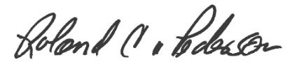
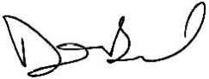
Sincerely,

Senator David Bullard Senator Roland Pederson
Oklahoma State Senate Oklahoma State Senate

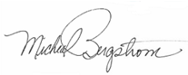

Senator Micheal Bergstrom Senator Dana Prieto
Oklahoma State Senate Oklahoma State Senate

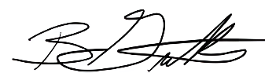
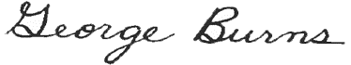
Senator George Burns Senator Brian Guthrie
Oklahoma State Senate Oklahoma State Senate
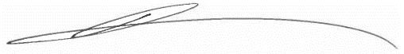

Senator Jonathan Wingard
Oklahoma State Senate

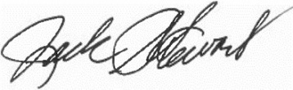
Senator Jack Stewart
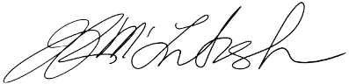
Oklahoma State Senate

Senator Julie McIntosh
Oklahoma State Senate

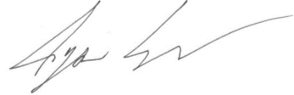
Representative Ryan Eaves
Oklahoma State House of Representatives
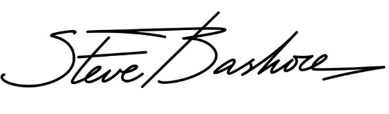
Representative Steve Bashore
Oklahoma State House of Representatives
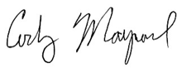
Representative Cody Maynard
Oklahoma State House of Representatives
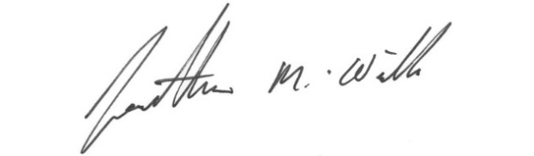
Representative Jonathan Wilk
Oklahoma State House of Representatives
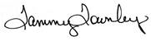
Representative Tammy Townley
Oklahoma State House of Representatives
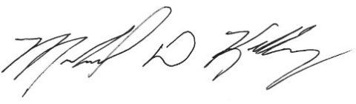
Representative Mike Kelley
Oklahoma State House of Representatives
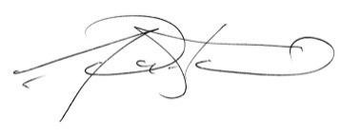
Representative Gerrid Kendrix
Oklahoma State House of Representatives
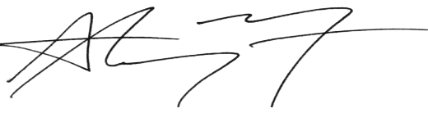
Representative Anthony Moore
Speaker Pro Tempore
Oklahoma State House of Representatives
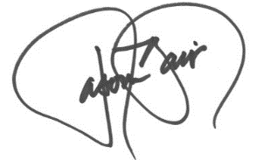
Representative Jason Blair
Oklahoma State House of Representatives
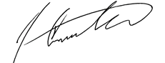
Representative Josh Cantrell
Oklahoma State House of Representatives
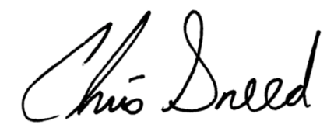
Representative Chris Sneed
Oklahoma State House of Representatives
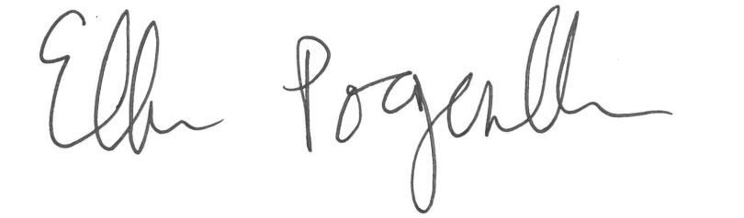

Representative Ellen Pogemiller
Oklahoma State House of Representatives
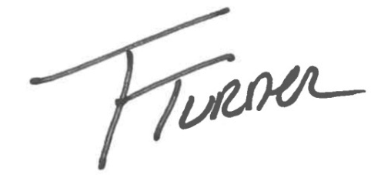
Representative Tim Turner
Oklahoma State House of Representatives
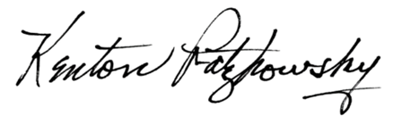

Representative Kenton Patzkowsky
Oklahoma State House of Representatives
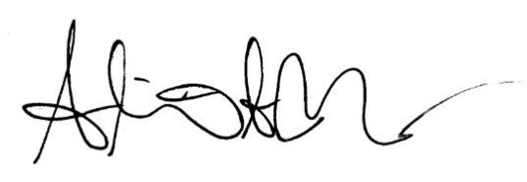
Representative Annie Menz
Oklahoma State House of Representatives
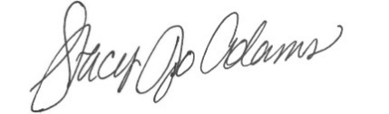
Representative Stacy Jo Adams
Oklahoma State House of Representatives
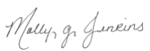
Representative Molly Jenkins
Oklahoma State House of Representatives
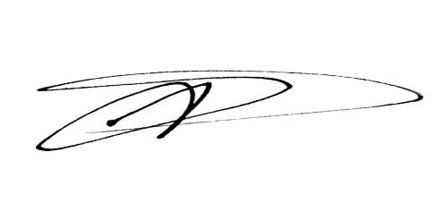
Representative T.J. Marti
Oklahoma State House of Representatives
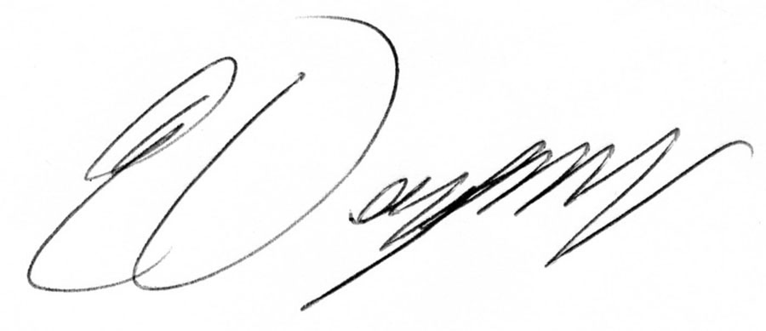
Representative Eddy Dempsey
Oklahoma State House of Representatives
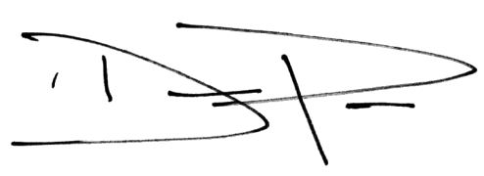
Representative Daniel Pae
Oklahoma State House of Representatives
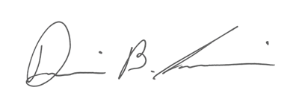
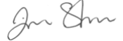
Representative Jim Shaw
Oklahoma State House of Representatives

Representative Dillon Travis
Oklahoma State House of Representatives

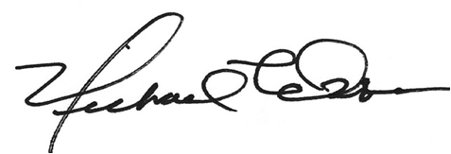

Representative Mike Osburn
Oklahoma State House of Representatives
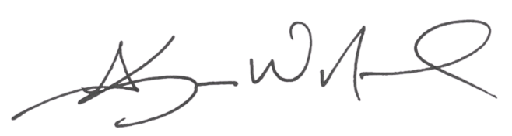

Representative Kevin Norwood
Oklahoma State House of Representatives
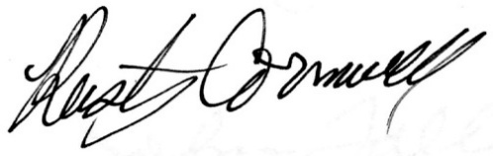
Representative Rusty Cornwell
Oklahoma State House of Representatives
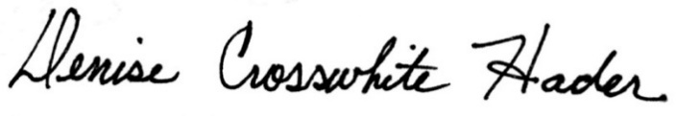
Representative Denise Crosswhite Hader
Oklahoma State House of Representatives
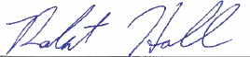

Representative Rob Hall
Oklahoma State House of Representatives
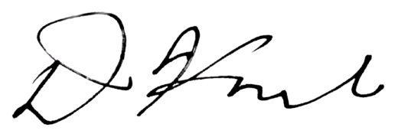
Representative David Hardin
Oklahoma State House of Representatives

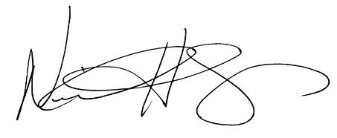
Representative Neil Hays
Oklahoma State House of Representatives
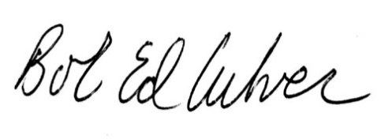
Representative Bob Culver
Oklahoma State House of Representatives
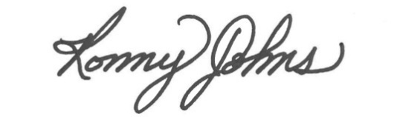
Representative Ronny Johns
Oklahoma State House of Representatives
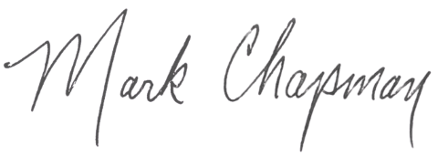
Representative Mark Chapman
Oklahoma State House of Representatives
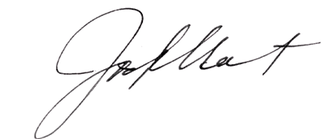
Representative Josh West
Oklahoma State House of Representatives
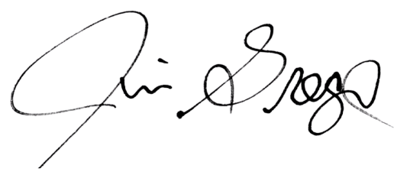
Representative Jim Grego
Oklahoma State House of Representatives
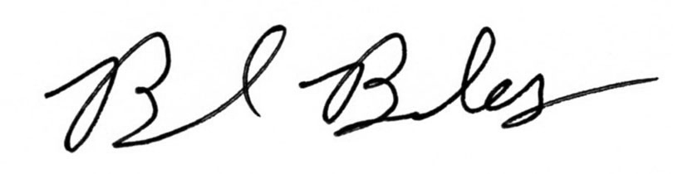
Representative Brad Boles
Oklahoma State House of Representatives
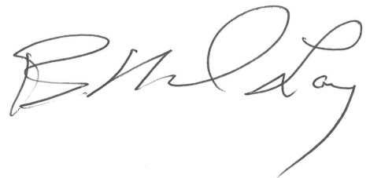
Representative Mike Lay
Oklahoma State House of Representatives
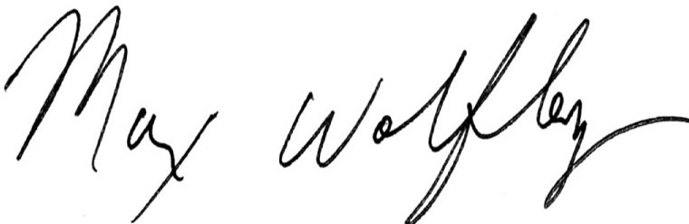
Representative Max Wolfley
Oklahoma State House of Representatives
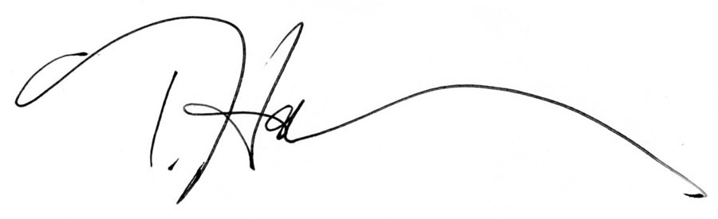
Representative Toni Hasenbeck
Oklahoma State House of Representatives

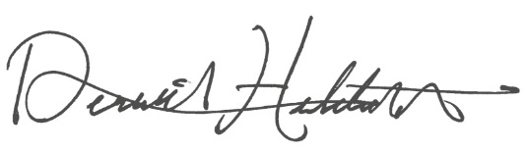
Representative Derrick Hildebrant
Oklahoma State House of Representatives
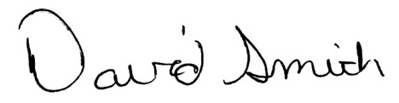
Representative David Smith
Oklahoma State House of Representatives
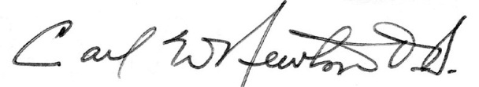
Representative Carl Newton
Oklahoma State House of Representatives
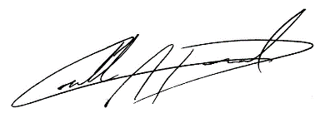
R
Representative Collin Duel
Oklahoma State House of Representative

